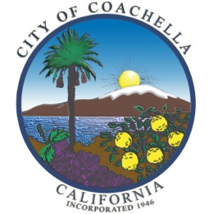
CITY OF COACHELLA

Equity and Social Justice
AdHoc Subcommittee Application

Application deadline is 6:00 p.m. on Friday, September 1, 2023
Application must be received by the deadline in order to be considered

Name: _____________________________________________________________________________

Address: ___________________________________________________________________________

Telephone: ______________________________ E-mail: _________________________________

To be eligible for appointment to the Subcommittee you must be a resident of the City of Coachella. Members may only serve on one commission/committee.

Please Furnish Brief Responses to the Questions Below:

1. Why do you think you should be appointed? What is there specifically in your background, training, education and interests that qualifies you as a candidate?

__________________________________________________________________________________

__________________________________________________________________________________

__________________________________________________________________________________

__________________________________________________________________________________

2. What do you see as the goals and objectives of the Subcommittee? How would you help achieve these objectives and goals?

__________________________________________________________________________________

__________________________________________________________________________________

__________________________________________________________________________________

__________________________________________________________________________________

3. What special qualities can you bring to the Committee?

__________________________________________________________________________________

__________________________________________________________________________________

__________________________________________________________________________________

4. Do you have any questions or comments about the Committee’s structure or functions?

__________________________________________________________________________________

__________________________________________________________________________________

__________________________________________________________________________________

__________________________________________________________________________________

5. Other comments and/or ideas as to how you as a member of the Equity and Social Justice Adhoc Subcommittee could benefit the City of Coachella.

__________________________________________________________________________________

__________________________________________________________________________________

__________________________________________________________________________________

__________________________________________________________________________________

Signature Date

Please Return this Completed Application to:

City of Coachella
53-462 Enterprise Way
Coachella, CA 92236

cityclerk@coachella.org

(Revised 02-14-2023)

